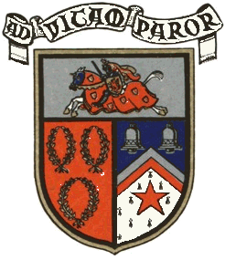
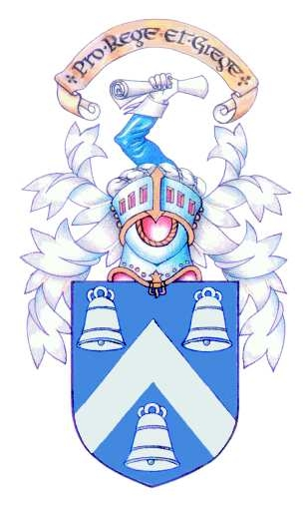
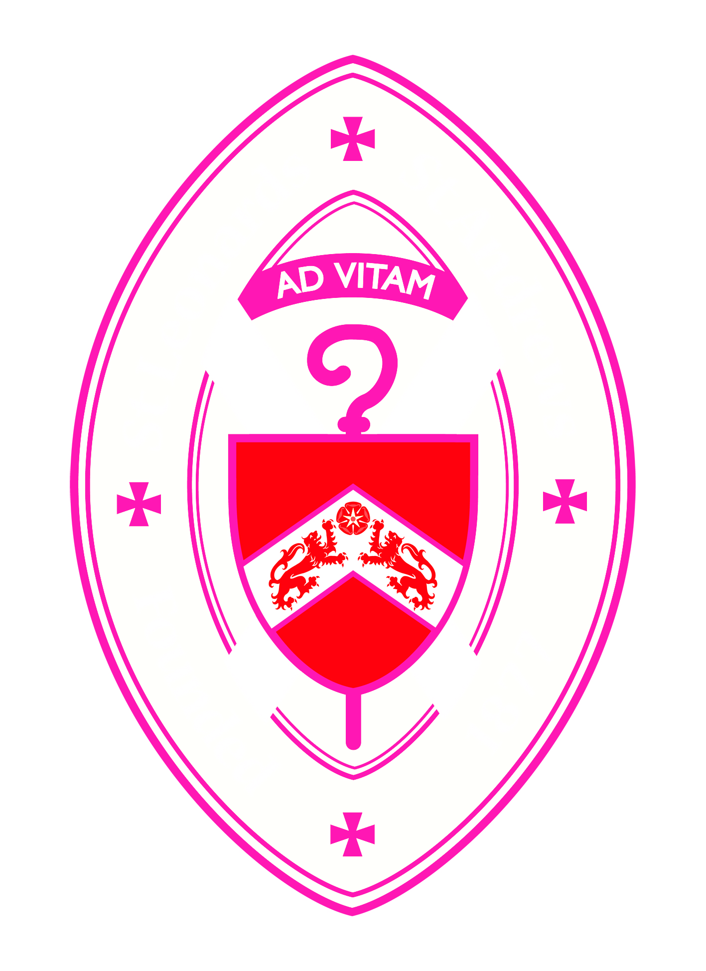
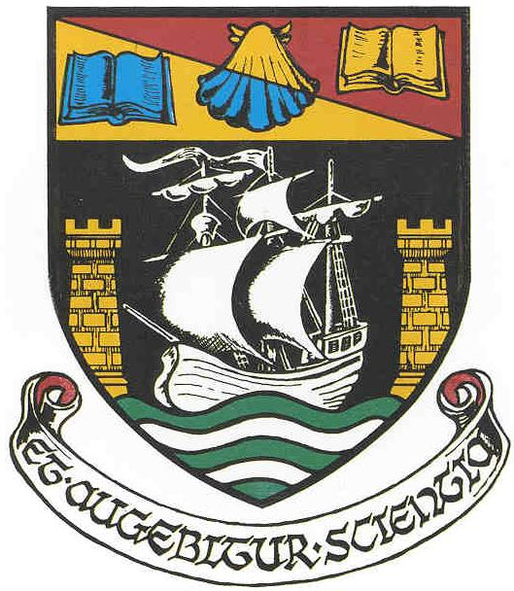


St Andrews Rotary Club
and the
Senior Schools of N. E. Fife Proudly Present

A Musical Celebration of Our Youth in Concert

At Madras College,
Kilrymont Road
St Andrews

Wednesday 20th March at 7pm

Tickets available from Madras College, Bell Baxter School, Waid Academy
and St Leonards School

Price £4. All proceeds to Rotary Charities and to the Participating Schools

